Instructions for using the upper computer
- Because the implementation of different manufacturers is different, the power control function of the reader module needs to be realized by the handheld manufacturers themselves。
- The default serial port device is / dev / ttyMT1. You can modify the serial port devices in the settings. After setting up the upper computer, open the upper computer again。
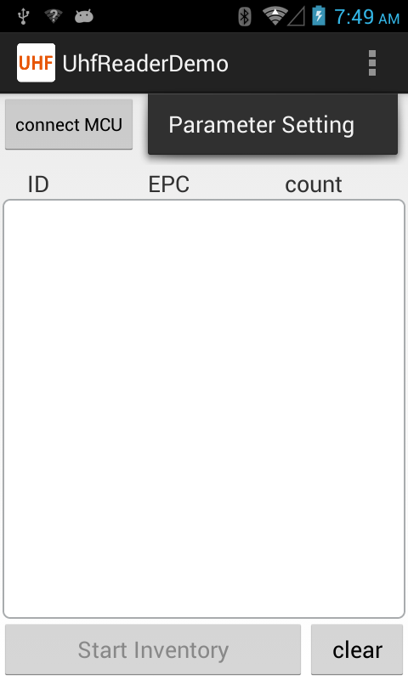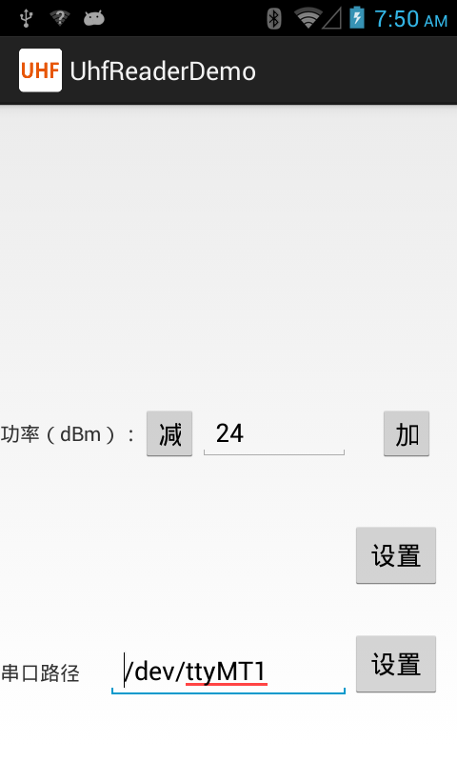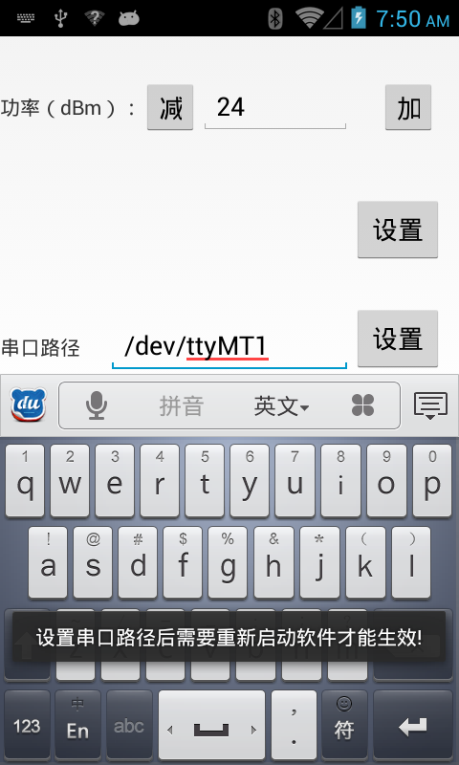
Upper computer interface
